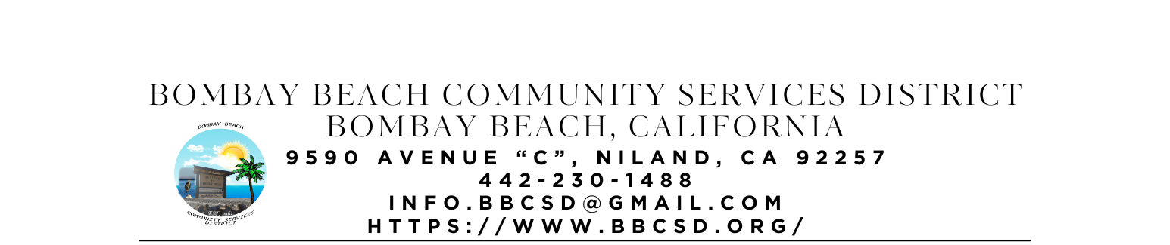
SPECIAL CALLED MEETING AGENDA
Board of Directors
Paedrin Fusco – Board Chair Date: NOVEMBER 20, 2025
Cameron Leslie – Vice Chair Time: PUBLIC SESSION: 12:00 PM
Robin Booth
Theresa Lamer Place: 9590 Avenue C
Steven Johnson Niland, CA 92257

- CALL TO ORDER:
  - Pledge Allegiance to the Flag
  - Roll Call to determine Quorum

- APPROVAL OF THE AGENDA: Board will approve the agenda for the SPECIAL CALLED Meeting for NOVEMBER 20, 2025, as is or delete/clarify any item on the agenda.

- APPROVAL OF MEEING MINUTES: Board will approve the meeting minutes from REGULAR SCHEDULED Meeting on OCTOBER 16, 2025, as is or delete/clarify any item on the agenda.

- OPEN FORUM/PUBLIC COMMENT: This is an opportunity for members of the public to address the Board on any subject matter within the Board’s jurisdiction, but not an item on the published agenda. Public Comment on agenda items will be allowed when the agenda item is called by the Board. Please make comments at podium, state name and limit comments to 3 minutes

- CONSENT AGENDA: “A Consent Agenda may be presented by the Board President at the beginning of a meeting. Items may be removed from the Consent Agenda on the request of any one Board Member. Items not removed may be adopted by general consent without debate. Removed items may be taken up either immediately after the Consent Agenda or placed later on the agenda at the direction of the assembly.”
  - FINANCIAL REPORT: Report on financial status of the district as of SEPTEMBER 30, 2025
    - Bank of America Account Ending in 1946 - $4,414.98
    - Bank of America Account Ending in 6398 - $500.00
    - Bank of America Account Ending in 5949 - $500.00
    - Bank of America Account Ending in 8163 - $500.00
    - 5 Star Account Ending in 3549 - $20,940.00
    - 5 Star Account Ending in 3557 - $54,281.27
    - Total Amount of District Bank Account Funds - $81,136.25
  - The Board will approve payment of accounts payable in the form of Demands to the County. A copy of the list of Demands is available upon request.
  - The Process to establish Emergency Response Unit. (ERU Coordinator and ERU Admin)
  - The Board will hear an update on the Process to Acquire the Fire Department Building at Bombay Beach. (Fusco)
  - What to do with the Large Water Pump that belongs to the district. (ERU Admin)
    - Working with someone at Gov Deals to get it listed for Auction
  - The Board will hear an update on the Establishment of a Local Mass Texting or Information Dissemination Service for Bombay Beach Residents. (Youngberg)
    - Looking into LED Message Board to Display in front of or on the side of the Community Cener
  - The Board will hear an update on Park Grant. (Youngberg)
  - The Board will hear an update on District Kitchen Remodel (Booth took over project 02/2025)
  - The Board will hear an update on the Avenue A Beautification Project (Youngberg)

- ITEMS REMOVED FROM CONSENT AGENDA:

- OLD BUSINESS – DISCUSSION/ACTION ON THE FOLLOWING:
  - The Board will hear an update on Constructing a Fence to separate the trash dumpsters lot from the adjoining lot. (Youngberg – item introduced 06/15/2023)
  - The Board will hear an update on the Purchase and Installation of Security Camera System (Lamer introduced 01/16/2025)
  - The Board will hear an update on Replacement and or Repair of Bulletin Boards at each mailbox location in town for easier sharing of information. (Fusco/Youngberg introduced 01/16/2025)
  - The Board will hear an update on Contacting CFO for CSDA about reviewing Financial Policies and Procedures (Johnson – introduced 05/15/2025)
  - The Board will hear an update on Contacting CSDA Partner about Utility Bill Review (Johnson – introduced 05/15/2025)
  - The Board will hear an update on the Purchase of a Shed/Storage Container for the District. (Leslie – introduced 05/15/2025)
  - The Board will hear an update on Expanding District Boundaries to include Spa Area through LAFCO and Public Outreach. (Booth/Leslie - introduced 05/15/2025)
  - The Board will discuss Accepting a Donation, including installation, from IV Equity and Justice of a Commercial Ice Machine, Water Dispenser, and Mister System for Patio to help combat the Extreme Heat and add to our Heat Resilience Project for Residents. (Lamer/Youngberg 06/19/2025)
  - The Board will hear an update on Purchase of a new Freezer with left over funds from Lasagnathon and Anonymous Donation made after the Convivium totaling $1970.00 (Youngberg – introduced 05/15/2025)
  - The Board will hear an update on Lease Negations with ATT and discuss what to do moving forward.
  - Board will discuss Community Fridge Idea presented by Jess (introduced May 15 2025)
  - The Board will discuss the Development of a Community Advisory Committee made up of residents to report back to the Board with issues and concerns heard from the residents. (introduced 06/19/2025)
  - Board will discuss first round of editing of BBCSD Policies and Procedures.

- NEW BUSINESS – DISCUSSION/ACTION ON THE FOLLOWING:
  - The Board will discuss the Trash Issues and Concerns from the Community and possible solutions. (Entire Board – introduced to keep as first new business item for every meeting until resolved or direction made by the Board to remove 05/15/2025)
  - Board will discuss filling out Self Evaluation Questionnaires and providing report during December meeting
  - Board will discuss filling out General Manager review every December
  - Board will discuss using remaining Trust for Civic life Grant Allocated for Community Events for Christmas Party – $2515.91

- COMMUNITY REPORTS:

- BOARD DISCUSSION/DIRECTIVES:

- DIRECTOR REPORTS:

- ADJOURNMENT:

