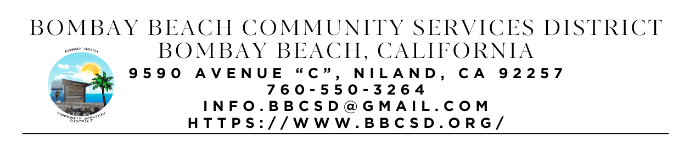

**SPECIAL CALLED MEETING MINUTES**

**Board of Directors**

Paedrin Fusco – Board Chair Date: FEBRUARY 11, 2025

Cameron Leslie – Vice Chair Time: 1:00 PM

Theresa Lamer Place: 9590 Avenue C

Steven Johnson Niland, CA 92257

1. **CALL TO ORDER:** 
   1. Pledge Allegiance to the Flag
   2. Roll Call to determine Quorum
      1. Director Fusco - Present
      2. Director Leslie - Present
      3. Director Lamer - Present
      4. Director Johnson – Present
      5. Quorum Established: Yes – Four out of Four Directors Present
2. **APPROVAL OF THE AGENDA:** Board will approve the agenda for the Special Called Meeting for February 11, 2025, as is or delete/clarify any item on the agenda.
   1. Motion to approve made by Director Johnson
   2. Seconded by Director Lamer
   3. Vote: 4-0-0
3. **APPROVAL OF MEETING MINUTES:** Board will approve the meeting minutes from Regular Scheduled Meeting on January 16, 2025 and Special called meeting on January 23, 2025, as is or delete/clarify any item on the agenda.
   1. Motion to Approve made by Director Johnson
   2. Seconded by Director Leslie
   3. Vote: 4-0-0
4. **NEW BUSINESS – DISCUSSION/ACTION ON THE FOLLOWING:**
   1. Board will discuss allowing Ivan use of the Fire Station as a place to host different productions in April during the closing weekend of the season.
      1. Notes: Ivan requested use of the Fire Station the Weekend of Apr 11th 2025 during the daytime hours and any donations made will go towards the ERU Fund
      2. Motion to approve Ivan use of the Fire Station made by Director Johnson
      3. Seconded by Director Lamer
      4. Vote: 4-0-0
      5. Motion to amend prior consent to use Fire station in that Ivan must provide prof of Insurance in order to use the Fire Station made by Director Johnson
      6. Seconded by Director Fusco
      7. Vote: 4-0-0
   2. Board will discuss allowing District Secretary to spend an allotted amount of funds to go towards Auggies Celebration of Life.
      1. Notes: 3 Bottles of Auggies Favoite Scotch - Dalmore
      2. Motion top approve Secretary the amount of $200.00 to use towards Auggies Celebration of Life made by Director Johnson
      3. Seconded by Director Lamer
      4. Vote: 4-0-0
   3. Strategic Planning and Vision workshop with Roque Barros From IV Wellness Foundation
      1. Notes: Please see attached photos
5. **OPEN FORUM/PUBLIC COMMENT:** This is an opportunity for members of the public to address the Board on any subject matter within the Board’s jurisdiction, but not an item on the published agenda. Public Comment on agenda items will be allowed when the agenda item is called by the Board. Please make comments at podium, state name and limit comments to 3 minutes.
   1. Notes: AJ made a comment about putting a fence up between her property and Dumpster site. Dulcinee Announced Community Forum at the Ski Inn on Sunday Feb 16th with Pot Luck 6-7pm and Meeting starting at 7pm. Auggies Memorial Sat 22nd at 2pm and Legion for Prayer and Ski Inn at 4pm for Pot Luck and Karaoke. Kids Club Planing Meeting changed to Fridays at 3:30pm
6. **COMMUNITY REPORTS:**
7. **BOARD DISCUSSION/DIRECTIVES:**
8. **DIRECTOR REPORTS:**
9. **ADJOURNMENT:** Meeting Adjourned by Director Leslie at 2:46pm Seconded by Director Lamer Vote: 4-0-0

